**Nguyễn Mạnh Bảo Tín MSSV: SE170134**

**Subject: DBI202 Class: SE1712**

**LAB 3**

Database Diagram

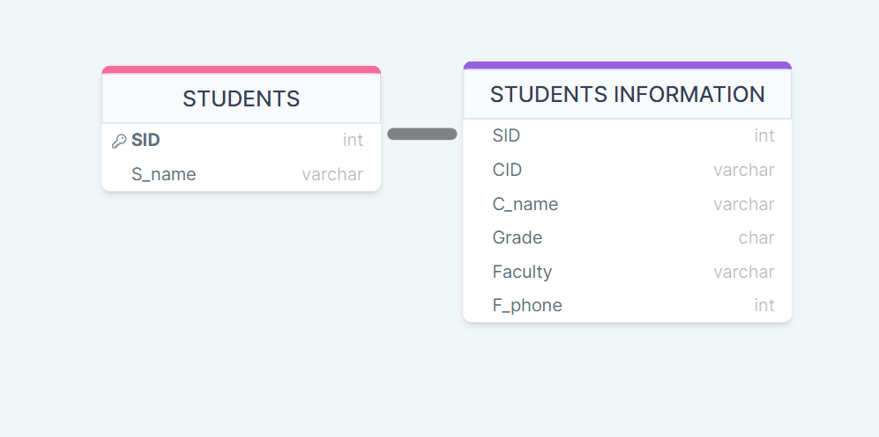

Database in SQL

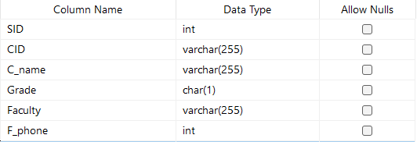

*Student’s information table form.*

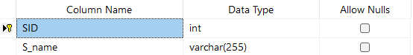

*Student’s ID and name table form.*

Entry Example

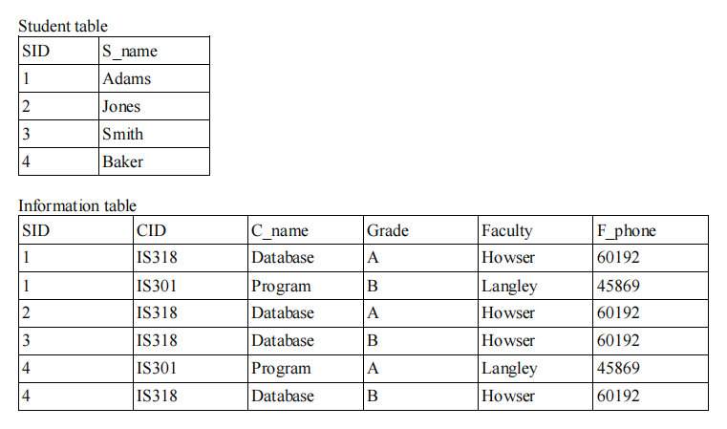

Entry in SQL Database

